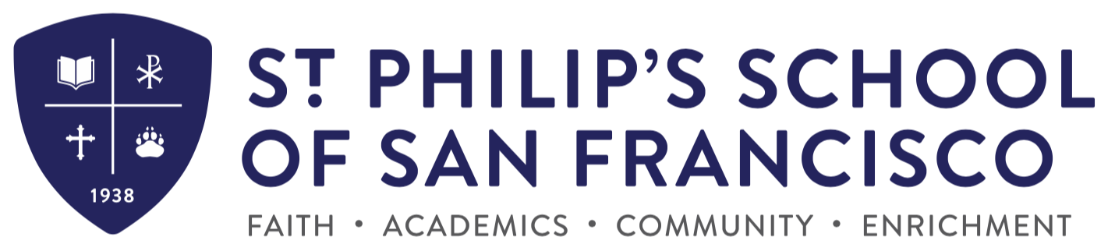

Application Process & Key Dates Grades 1-8 (2022-2023)

- Download the application packet on the school website. You may also call the school office (415 824 8467) and arrange to pick up an application.

- Completed Application Packets must include:
  - Completed application form
  - Copies of Birth and Baptism Certificates
  - Current record of all immunizations
  - Recent report card from current grade, final report card from prior grade, and copy of the standardized test results (where applicable).
  - $75 non-refundable application fee
  - Applications for Grades 1-8 for the 2022-2023 school year is an ongoing process; the last date for accepting applications is February 18, 2022.

- Arrangements for shadow days can be made by contacting the school office (415-824-8467). Shadow days are applicable to incoming 3rd through 8th grade students only.

- An assessment will be given by the school; arrangements to complete this can be made by calling the school office (415 824 8467)

- When you are notified of your child’s acceptance, you will also receive the enrollment packet. This must be submitted within 2 weeks of acceptance to hold placement. The enrollment process requires you to complete the forms and include the non-refundable Enrollment Fee of $550.

